Stage 3 Democracies

By
Daniel Raphael, PhD

53.08-STAGE-3-DEMOCRACIES

\Books \ 53-Stage.3.Democracies | 2.16.2021 | 14:52 | Words: 8 736

Stage 3 Democracies
© Copyright Daniel Raphael 2020 USA.

Excerpts and forwarding are permitted when
© Copyright remains intact.

Stage 3 Democracies

Daniel Raphael, PhD

— opus unius hominis vitae —

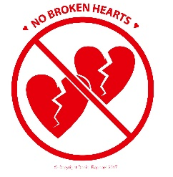

No Broken Hearts is an imprint of
Daniel Raphael Publishing
~
Daniel Raphael Consulting
PO Box 2408, Evergreen, Colorado 80437 USA
Stage 1, 2, and 3 Democracies are briefly discussed on page 11; and, far more thoroughly discussed in The Progressive’s Handbook for Reframing Democratic Values, pages 79-112. Available from the author’s website.
Stage 2 Democracies, as the United States, are governed by rule-bound leadership. Now that the Covid-19 Pandemic has created a turning point for democratic cultures, it is timely to encourage values-based leadership, values-based decision-making, and to initiate values-based organizational development.
The 3rd Stage of Democracy is to the 2nd Stage
As democracy was to the monarchy.
The 3rd Stage of Democracy is to the 2nd Stage
As smart phones are to rotary dial phones.
The 3rd Stage of Democracy is to the 2nd Stage
As Python is to BASIC,
And as digital technologies are to analog
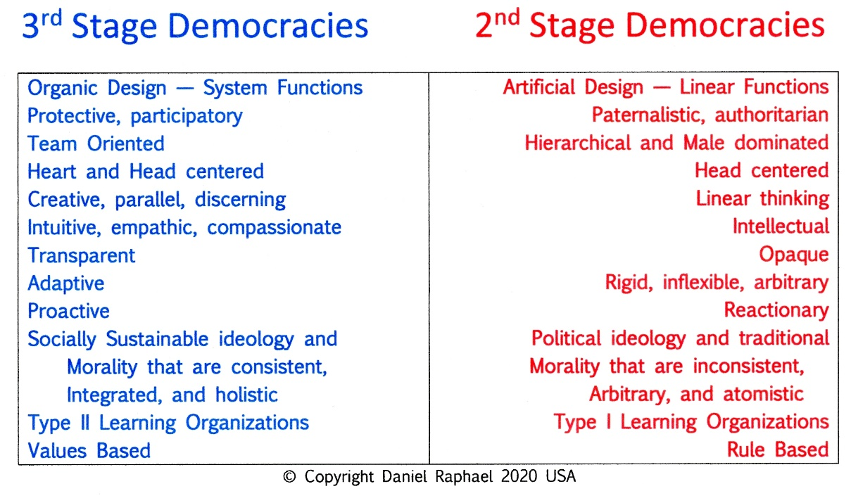
technologies.
The people who will gravitate to the initiation and implementation of Stage 3 Democratic systems are those who are now the disenfranchised, the 18-28, and 28-38 year old citizens. They have everything to gain. The future belongs to them! Here’s how they can own it.

Contents

TABLE: A Comparison of Stage 3 and Stage 2 Democracy Characteristics 3

Statement of Intention 5

A Changing Mindset 7
TABLE: A Comparison

1. The Primal Cause for the Development of Democracies and their Evolution 9
TABLE: Stage 3 Democracies Compared to Stage 2 Democracies 9
The Seven Primary Social Architectural Structures Necessary to
Support Stage 3 Democracies
1. Organic, Innate, Universal, and Timeless Values
ILLUSTRATION: Seven Values Have Sustained Our Species Survival
2. A Universal and Timeless Code of Ethics and Morality
3. Understanding Human Motivation as the Cause for Political Evolution
4. Understanding the Cause of Incessant Social Change
TABLE: The Apportionment Act of 1911
5. Qualitative and Quantitative Definitions of Equality
6. Building on Stage 2 Democracies
7. Whatever We Re-Design Must …

2. The Basics that Support Stage 3 Democracies 19
A. TABLE: SUSTAINABILITY – Material Sustainability / Social Sustainability 19
B. An Explanation of Survival, Existence, and Sustaining
The Four Primary Values – Life, Equality, Growth, and Quality of Life
TABLE: Seven Values have Sustained Our Species’ Survival 21
The Three Secondary Values that Make us Human – Humane
TABLE: The Characteristics of the Primary and Secondary Values 22
A Proactive Ethic and Morality
The Logic Sequence of a Proactive Ethic and Morality

3. The Mechanics of Initiating Stage 3 Democracies 27
1. Facilitator
2. EM21 – Public Media
3. Local Community Design and Validation Teams
4. The Library of Sustaining Human Wisdom
5. The Development and Initiation of a “Stage 3 Political Party”

Discussion 31

The Antidote to the Apportionment Act of 1911 33
ILLUSTRATION: Priorities of Decision-Making in a Socially Sustainable Society 35
Example: Raphael’s Design and Validation Schematic 36

Bibliography 37

Author’s BIO and Contact Information 38

Statement of Intention

The intention for this paper is to create highly beneficial, values-based, non-violent, evolutionary improvements to the democratic processes of mature Stage 2 Democracies.
The table on page 3 provides a list of the characteristics of mature Stage 2 Democracies of the world; and juxtaposed to that is the list of desirable characteristics of Stage 3 Democracies. Public movement toward accepting Stage 3 is already underway. Stage 3 Democratic systems will define those nations that will sustain their survival and thriving existence into the future. Stage 2 Democracies that do not accept this evolutionary movement will eventually cease to exist.
This paper will describe the main social architectural supports that will sustain the existence of Stage 3 Democracies into the centuries ahead. The best feature of the initiation of Stage 3 Democracies is that they will come into existence without revolt, rebellion, or revolution. We can, however, anticipate that those citizens and public officials who are deeply embedded in Stage 2 Democracies will take great effort to retain the characteristics of those Stage 2 Democracies that benefit them. Their arguments will be powerful and pointed, but of no effect to change the character of human motivation and its overriding need for democratic systems that support the development of each citizen’s innate potential.

Strategic Planning

“Strategic planning is worthless — unless there is a strategic vision.
A strategic vision is a clear image of
what you want to achieve,
which then organizes and instructs
every step toward that goal.

John Naisbitt, Megatrends, 1982

A Changing Mindset

The movement of democratic processes of Stage 2 Democracies to Stage 3 Democracies systems is not simply a change to a new form of democratic system. It goes far deeper than that and involves a new “mindset” of thinking that is not traditional. For example —
The habits and ideology of traditional Stage 2 thinking is to work hard to keep from failing.
The habits and ideology of progressive Stage 3 thinking is to work hard to sustain succeeding.
Stage 2 thinking is linear and invested in competition that expresses as either-or, us-them, us-or-them, our-way-or-the-highway, insiders-outsiders, and winner takes all. Its strategy is to divide and conquer.
Progressive Stage 3 thinking is invested in us, we, us-and-them, together, and mutual solution-finding that lends to cooperation rather than competition to resolve mutual problems. Its strategy is integral — together we can succeed.

NOTE: The word “progressive” is not used in this text to denote a political party or political ideology. Rather, it is used to denote a cultural ideology that promotes a broader and more holistic approach to the resolution of societal progress and evolution.
—

1
The Primal Cause for the Development of Democracies and Their Evolution

The materials within this brief paper came from The Progressive’s Handbook for Reframing Democratic Values, available from the following websites
https://sites.google.com/view/danielraphael/free-downloads
www.bigmacspeaks.life
www.academia.edu

All contemporary developed democracies around the world are Stage 2 Democracies including the United States, Canada, Australia, New Zealand, Japan, the Nordic nations, the UK, France, Italy, and many others. For contemporary democracies to remain viable into the future, all must adapt to social change to evolve to become Stage 3 Democracies. Please see the table below for a comparison.

The seven primary architectural structures necessary to sustain Stage 3 Democracies are described below. Most Stage 2 Democracies are experiencing many social, political, and economic problems that are really symptoms of the failure of Stage 2 Democracies to adapt to the social change of their publics. As Stage 2 Democracies are of linear designs and rule based, without integrated learning systems, (Type I Learning), their politics and governments have been left behind, and have become more and more antiquarian with each passing decade.

The Seven Primary Social Architectural Structures
Necessary to Support Stage 3 Democracies
1
Organic, innate, universal, and timeless values.
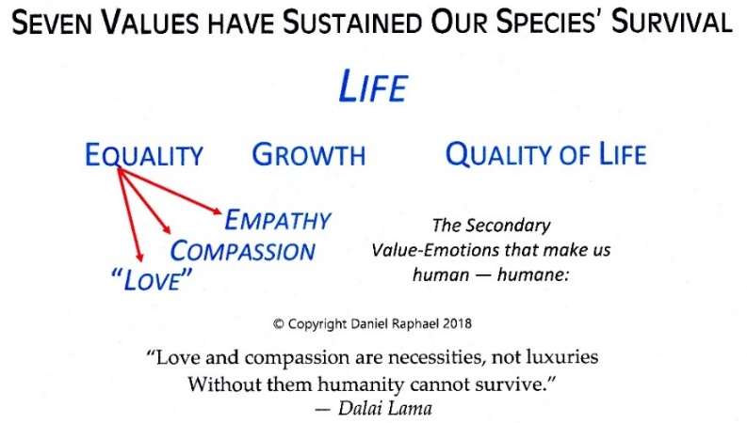
What truly sets Stage 3 Democracies apart from every other type of governance and Stage 2 Democracies is that Stage 3 Democracies are designed to become socially sustainable. Social sustainability is based upon the same values that were used to underlie our ancient ancestors decisions 200,000 years ago that sustained the survival of our species. Those values were used by them, and therefore, we are here today! Those values are illustrated below.

2

A universal and timeless code of ethics and morality. Any set of values automatically sets up a tension between using those values or not using them. As an example, using “equality” as the tension-causing value generates normative statements of “should” and “ought to.” Should I treat others equally as I treat myself? Statements as that are ethical statements.
The use of the word “ethic(s)” in this text relates to the good maintenance of relationships with others. “Morality” on the other hand in this text relates to supporting the life and living of others.
The seven values illustrated above provide humanity with a universal and timeless code of ethics and morality. While all theories of ethics are values-based, NONE are based on values that are universal, timeless, innate, and organic to all people. In other words, these seven values provide permanent ethical and moral standards for decision-making that will sustain societies.
3

Understanding Human Motivation as the Cause for Political Evolution. Any set of values automatically sets up a tension between using those values or not. That tension is the impetus for decision-making. Those seven values provide the urge, the motivation to decide, and to move ahead with the desired end result being the fulfillment of those values.
Stage 1 Democracies come into existence in pre-revolutionary incubation eras that precede riots, rebellions, revolts, and revolutions. The vital necessity for fulfilling our innate seven values is the freedom and the liberty that is needed for liberty and self-determination to reign.
Stage 2 Democracies come into existence as a result of revolution against monarchies, despotic rulers, tyrants, and dictators. The authors of the Declaration of Independence intuitively knew that the innate and organic values of people are directly connected to the self-evident rights of humankind to form a government that would enable and empower citizens to make decisions on their own behalf.
In the case of mature Stage 2 Democracies, the political rights of self-determination of its citizens have not kept pace with the social changes of their publics. The need for the expansion of the rights of self-determination was not incorporated into the Constitution in 1789-91. That is work that is more suited for progressive interests to design.
Democratic government, being founded on the values that are innate to our species, is the only form of government where people have the liberty to freely express their innate needs of self-determination to develop their innate potential. And it is because of the continuing urging of those values that the public chafes against their Stage 2 democratic government that has failed to adapt to the social change that is organic to the motivation of those values in people. Within only twenty-four years, Thomas Jefferson had already sensed that something was amiss in his new United States.

"I am not an advocate for frequent changes in laws and constitutions. But laws and institutions must go hand and hand with the progress of the human mind. As that becomes more developed, more enlightened, as new discoveries are made, new truths discovered and manners and opinion change, with the circumstances, institutions must advance able to keep pace with the times...."
Thomas Jefferson, from a letter to Samuel Kercheval, July 12, 1816.
4

Understanding the Cause of Incessant Social Change. One of the failures of Stage 2 Democracies that Stage 3 Democracies will have overcome is the capability to adapt to social change that is endemic to all societies. For the Stage 2 American democracy, the biggest political (social) change that occurred was the passage of the Apportionment Act of 1911, that eventually gutted citizen representation in Congress.
Hindsight being 20-20, the consequences of the Apportionment bill probably were not known ahead of time by members of Congress, but rather became an unanticipated development of its passage.
“Less than 1%” The founding authors of the US Constitution foresaw the necessary growth of the House of Representatives as populations grew. More representatives were needed to represent new populations. Between 1789 and 1911, there was one representative for every 3,000 citizens. In 1911, it was realized that the House of Representatives had become so large and unwieldy in its procedures that the number of representatives was fixed by the “Apportionment Act of 1911” at 435 members. After 1911, population increases were apportioned to each representative.
The Apportionment Act of 1911
1789-1911 3,000 citizens to 1 Representative
2016: 735,000 citizens to 1 Representative
(2016 320,000,000 citizens to 435 Representatives)
Today, that represents a decrease of 99.9960% of influence individuals have with their elected representative compared to the influence citizens had until 1911.
[3,000 ÷ 735,000 = 0.0040]; {100% – 0.0040 = 99.9960% }
Effectively, the average individual is no longer represented by the Congressional Representative
they elect to office, which has created a “vacuum of influence.”

Consequently, it is naïve to believe that the transformation of Stage 2 Democracies to Stage 3 Democracies will occur by way of state or congressional action. It is once again upon the shoulders of individual citizens to intelligently gather together similarly as did the founders of every national democratic government to establish a nation and government of the people, by the people, and for the people.
From Abraham Lincoln in his Gettysburg Address: "That this nation, under God, shall have a new birth of freedom – and that government of the people, by the people, for the people, shall not perish from the Earth.”
He easily could have added, “…as long as that government is fully in synch with it being “of the people, by the people, and for the people….” As we of the United States have so clearly seen in the last 50 years, our government is no longer operating within those parameters.
—
Social Change and Adaptation. Historically, the organizational existence of people has taken the form of clans, tribes, tribal nations, dynasties, empires, international nations, cultures, societies, and civilizations. In the last 30,000 years of organizational social existence NONE of those forms of governance or associations have sustained their functional existence to the present time. Said another way, ALL FAILED because they failed to adapt to changing conditions.
Discern This Closely
It is not changing conditions that cause the downfall of societies, but the failure of societies to adapt to those changing conditions. The survival of any species is reflected in their ability to adapt to changing conditions. Adapting means growing when change occurs.
A failure to adapt, a failure to learn from experience. The irony of our ideals of freedom and liberty is that democracies are not perfect, and never will be. Democracies are not perfect because they consist of developmental social organizations, where each developmental stage of democracy provides the preparation to evolve to the next developmental stage. The nature of evolving democracies is to provide adaptive democratic governing systems that maintain the principles of liberty and the right of self-determination by its citizens, without jeopardizing the sustainable existence of its societies and its citizens.
Of all the forms of government, only democracy has the potential to adapt to the organic nature of those it governs. All other forms of governance are static and ultimately UNsustainable. The problem that maturing Stage 2 Democracies have not resolved is the means to take into account social change, change that is organic and innate to our species. Stage 3 Democracies are designed to take into account the constant nature of social change of the public.
In Stage 2 Democracies—
Responsibility to society is indoctrinated
by rules, authority, obedience, and discipline.
In Stage 3 Democracies —
Responsibility for society is enculturated
by teaching personal power,
self-discipline, and personal responsibility.
5

Qualitative and Quantitative Equality. Much like a perennial plant or tree, our traditional form of democracy has grown to its design limits — particularly when that limit is quantitatively defined in the historic interpretation of the word “equal” in that most famous of sentences from the Declaration of Independence. The emphasis is on the word “equal.”
“We hold these truths to be self-evident, that all [people] are created equal, that they are endowed by their Creator with certain unalienable Rights, that among these are Life, Liberty and the pursuit of Happiness.”
Quantitative Equality was fulfilled to its inherent limits by the end of the 20th century with the passage of the last “equal rights” legislation. This is evident from the detailed record of voting rights expansion from 1790 to 1965, as example. The conclusion we can gain for quantitative voting rights progress from 1790 to 1965 is that the quantity-object based interpretation of equal in the Declaration has been explored to its fullest extent that completes Stage 2 of Democracy. (See illustration p. 19.)
Qualitative Equality. What we have not realized for the last 230 years, approximately, is that a quality-value based interpretation is as equally valid as the quantity-object interpretation. The error that has short-changed the social and political evolution of every democratic nation is that the word “equal” assumes the unspoken word “value” as a quantity.
In a fully functional Stage 3 Democracy, citizens are valued as a quantity of one equal to every other citizen — and, also valued equally for the quality of their participation in the democratic process. Increasing their participation increases their value to a Stage 3 Democracy. Currently, if a person does not vote, then the quality of their voting potential drops to zero. As this has been interpreted as a quantity of one, the quality of a citizen is either 100% or 0.0% depending upon whether he or she votes or not.
The whole point of the Declaration was to declare [people] as having equal value as the king. What was not made emphatic was the interpretation of the word “equal.” The king had the quantity of one, and the quality of one!
Because there is no emphatic interpretation of the word “equal” in the Declaration, or the Constitution, we can assume that qualitative and quantitative interpretations are equally valid. Only the quantitative interpretation, however, has enjoyed its complete development in the American representative form of democracy.
Because the first interpretation deals only with quantities, it can only be taken to its quantitative limit where everyone enjoys equal representation. Regardless of race, gender, religion or property ownership everyone today is represented equally, i.e., one person, one vote. By 1965 the quantitative criterion of equal representation had nearly been fulfilled. The fullest outcome of the quantitative definition had been expressed. We are now at a dead end with it.
One set of outcomes. The great difficulty of using only one interpretation is that it allows for only one set of outcomes. Using both interpretations would allow two outcomes to come into being. The difference of possibilities by empowering both definitions is much like the difference between having 88 musicians in an orchestra simultaneously playing or not playing one note on their instrument louder or quieter. Compare that to 88 musicians playing a full range of notes with all the variations that orchestral music is capable. When we think of citizens voting or not voting, compared to adding the quality of their participation to democratic processes in local, state, and national venues, then it becomes very clear there is a striking and dramatic difference the two interpretations provide. Which would you prefer?

6
Building on Stage 2 Democracies. To successfully build Stage 3 Democracies, we will need to retain the best design features of traditional Stage 2 Democracies that are working and that lend themselves to their improvement and effectiveness. These include,
1. The direct connection between the values stated in the Declaration of Independence and the seven values of Homo sapiens.
2. There already exist long term democratic processes in place that have produced a social, political, and economic culture of democracy that will lend itself to the public’s acceptance of a Stage 3 Democracy; and the qualitative interpretation of the word “equal.”
3. The First Amendment provides the context for the development of Stage 3 Democracies and the qualitative interpretation of the word “equal.”
4. The Internet is already in place that connects all democratic nations for similar democratic developments.
5. The first and second intention of the founders of the United States democracy are fulfilled: a) The Revolutionary Colonists successfully pushed the authority of the British monarch back to his homeland; b) to create a sovereign democratic nation.
6. There is a history and culture of local citizens meeting together to discuss and promote legislation…
7. … and share their views, perspectives, opinions, and preferences with their elected and appointed public executives.
“What is right? What Works?” One book that has been very influential for examining Stage 2 Democracies is “Breaking the Rules — Removing the Obstacles to Effortless High Performance,” by Kurt Wright. Wright’s book is eminently practical because he asks several questions that lead the reader to intuitively pragmatic answers. 1) “What’s right?” [The word “right” is interchangeable with the word “works” to become, “What works?”] 2) “What makes it right/work?” 3) “What would be ideally right/workable?” 4) “What’s not yet quite right/workable?” And, 5) “What resources can I find to make it right/work?” This system moves our inquiry from “fixing problems” to creating solutions.
Question #1 begins by asking what is working, rather than focusing on what is wrong, which is the usual point of inquiry. It also asks us to get to the intentions and purposes of the function of our inquiry, and acts much like a review of the basics, which often get lost in the shuffle of fixing problems or finding solutions. Question #2 truly forces us to inspect what motivates the “right working” of the situation. Again, it forces us to retain what works and isolate what is not working. Questions #3 asks us to reach into our vision for something that makes us stretch to fulfill the greater good. Only then, in question #4, are we guided to discover/reveal the factors that are not working well; and, in #5 we are guided toward the resources that become the change-agents for creating the solutions we are seeking.
7

Whatever We Re-Design Must …
1. …be compatible with the Constitutional framework of our nation, and offer an inventive means of linking the values of the Constitution with the innate, sustaining values of our species;
2. …recover the quality-value relationship that citizens had with their congressional public executives before it vanished after the Apportionment Act of 1911;
3. …become a democratic evolutionary development to bridge the democratic tragedy the Apportionment Act created; and,
4. …offer an inventive way to engage contemporary technologies to give millions of citizens an ongoing and continuous means of offering their collective intelligence (think in terms of “knowledge workers” in high tech industries) to create a “trend” of intelligent consensus to share with public executives.
5. …offer a means for public executives to receive ongoing feedback from constituents; and keep pace with social change and the ever-changing hierarchies of needs of citizens whose interpretations of the seven values are constantly evolving.

2
The Basics that Support Stage 3 Democracies
As you can see, the concepts of “self-sustaining survival,” “conscious and intentional decision-making,” and “conscious and intentional” use of a timeless and universal ethic and morality presently are not aspects of our daily living. To move into the social, political, and economic environments of Stage 3 Democracies, let’s begin by building associations beyond these seven timeless values, ethic and morality to now include “social sustainability.”

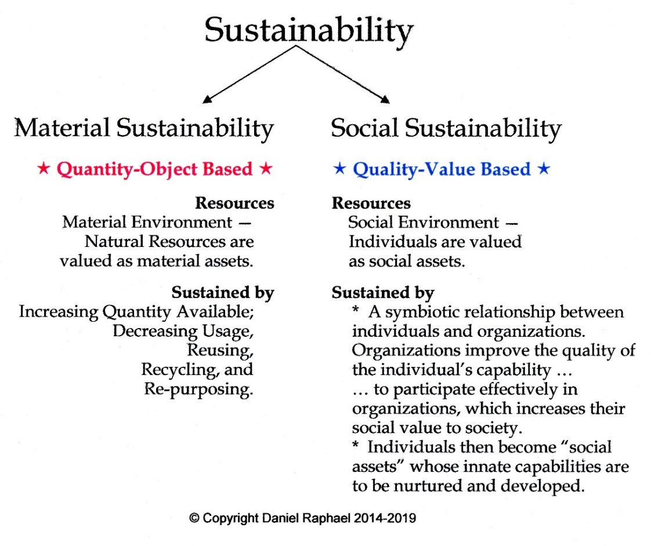
1. Table:

Because democracies are all about individual citizens and the public collective of citizens, the driving forces for the existence of democracies include the motivation and incessant urging of the seven values. For democracies to sustain their organizational existence, they must be deeply invested with the innate and organic values of people that drive social change.
“Social sustainability, the second aspect of sustainability, is quality-value based. Because decision-making is always values-based, a progressive agenda of social, political, and economic policies must be based on the seven values to add quality value to democratic citizens. (See below.) These values have not only sustained the survival of our species but have guided us to thrive and dominate the planet. This is the bedrock for building sustainable organizations, functional democratic governments, and democratically sustaining policies and statutes.”
(From The Progressive’s Handbook, p 37.)

2. An Explanation of Existence and Sustaining
The durations of existence.
Survival presents us with the immediate appreciation of life now and the threat of death within this day or the next.
Existence presents us with the necessity of assuring our survival over a period of time with death still being a constant reminder in our daily activities.
Maintenance presents us with the necessity of assuring our existence is maintained into an indefinite future. And this is the place where most people and their communities and societies exist — in an indefinite future.
Stability. As a society moves toward social sustainability it has begun the process of assuring it has a definite, peaceful, and stable future.

The duration of “sustaining” compared to survival, existence, and the maintenance of a society:
Sustain: To lengthen or extend in duration. This also implies a continuation of what exists already, which may not be sustainable.
Sustainable: Capable of being sustained in the long term.
Sustainability: The ability to sustain.
Social Sustainability: The ability of a society to sustain itself indefinitely…, for 5 years, 50 years, 250 years, 500 years and more because of the intention for its existence and the design of its functions.

The Four Primary Values —
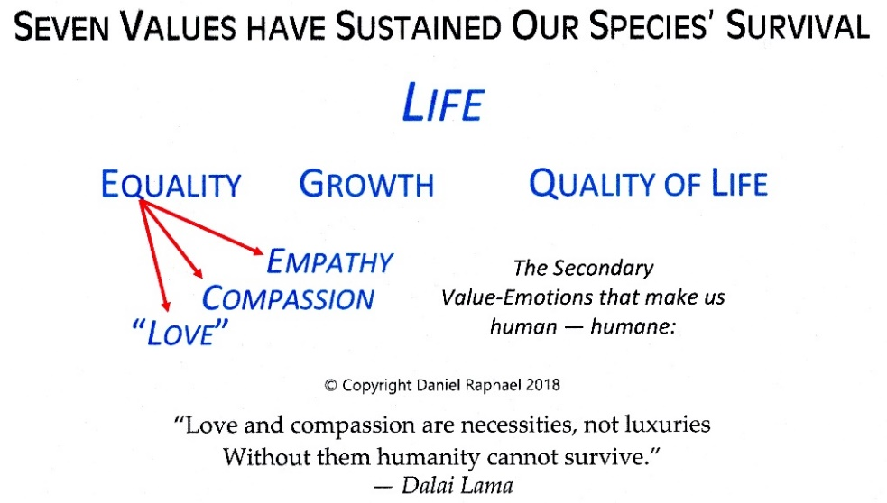
Life, Equality, Growth, and Quality of Life.

The four primary values are the values that urge individuals and humanity to thrive and progress to create and build nations and empires. Within the context of any society and culture, Equality, as a factor of human motivation, is more powerful as a culture-changing value than growth, quality of life, empathy, compassion, and a generalized love for humanity. As a factor of organized social existence, INequality has the motive force to create rebellion, revolt, and revolution. INequality is the motivating cause of the economic-based French Revolution of 1789, and the politically-based American Revolution; and can be pointed to as the motivating cause of almost all public-based revolutions that resulted in the development of some early form of democracy.
Fortunately, Equality is also the motive source for the human and humane value-emotions of empathy, compassion, and a generalized love for humanity.

Three Secondary Values that Make Us Human
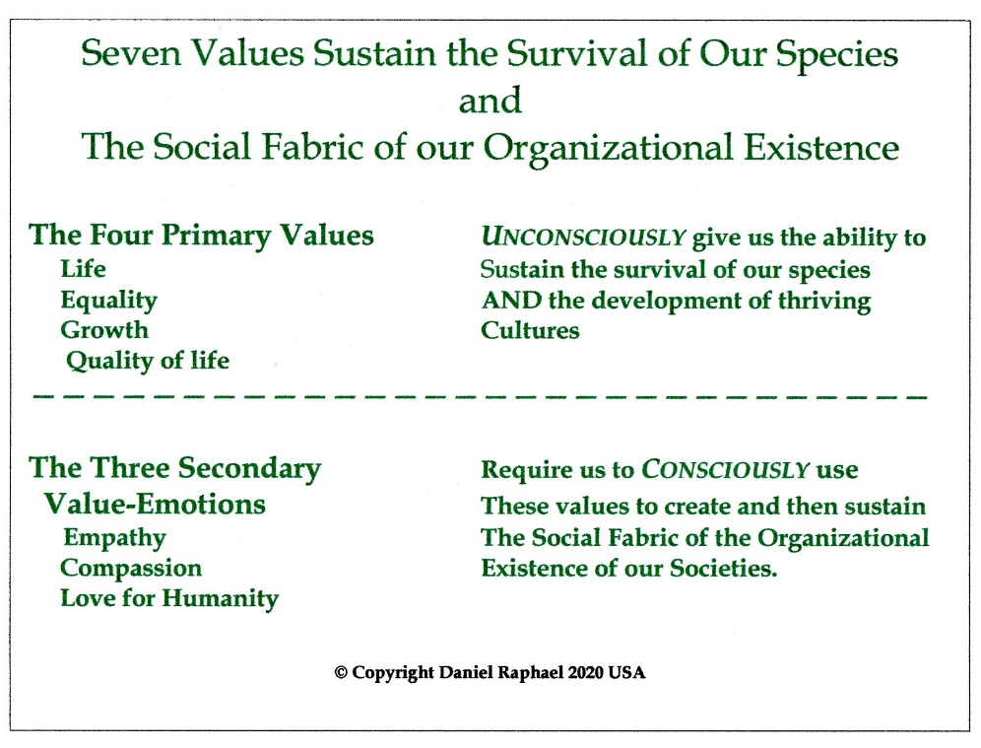
Equality Empathy, Compassion, and Love for Humanity

Being a slow and plodding thinker, it took me some time to figure out how the secondary values were also innate, timeless, and universal to our species. Long-story-short, they emanate from the primary value “Equality.” Equality by its very nature motivates us to compare our personal situation with that of others; and others to compare themselves to us.
The expression of the secondary values of empathy, compassion, and a generalized love for humanity are the value-emotions that identify our species as being human – humane. The table above reveals the significant differences between the primary and secondary values. The insight is that in order to express our humane treatment of others, we must consciously choose to act upon the urging and motivation of those values. Having said that, we can consider that those who have demonstrated themselves as predators toward other people are NOT human.
The reason we are so sensitive to issues of equality is that we have the innate capacity of empathy – to “feel” or put ourself in the place of another person and sense what that is like, whether that is in anguish or in joy. Feeling that, we have the innate value of compassion that motivates us to reach out to the other person and assist them in their plight or share in their joy. That is the “ethical moment.” We generalize empathy and compassion for all of humanity with the term Love – the capacity to care for another person or all of humanity, as we would for ourself.

A Proactive Ethic and Morality
Because values always underlie all forms of decision-making, and because these seven innate values are also innate to all people, avoiding the use of them is NOT an option for the moral and ethical person, or any organization. In other words, using these values requires a conscious awareness that NOT using them would offer the possibility that the decisions that are being made may be immoral and/or unethical.
That may seem very odd given that traditional ethics and morality have been used for thousands of years without a conscious thought of the values that support their use. That type of latitude was reasonable given that no one had ever truly identified the values that were being used for their decisions. But because all people are innately invested with the seven values, all people are inherently obliged to consciously use them in all their decision-making once they are made aware of their existence in order to sustain our species, (See illustration p. 35), and the organized existence of our societies and nations.
Consequently, the task remains to make people aware of the relationship between the seven values, their subsequent morality and ethics, and their decision-making. Personal consciousness of this relationship then becomes the mandate to hold individuals and organizations responsible for their decisions and actions.

Succinct Descriptions of Each Step of the Logic Sequence
Seven Values Moral Definitions Ethics Statements
Expressed Ethics The Graces of Expressed Ethics

NOTE: Below is a partial description of the proactive ethical and moral nature of these seven values. Further descriptions are provided in Chapter 3, “Ethics Statements for Each Moral Definition,” followed by Chapter 4, “Expressed Ethics,” from Making Sense of Ethics — A Universally Applicable Theory of Ethics, Morality, and Values.
The perspective these seven values provide is a proactive morality and ethic that will pervade all of the following discussions. Further, because of that proactive perspective, nothing is taken for granted as this morality and ethic will be new to everyone.
Identifying the Steps of the Sequence.
1. The first step is to begin with each value.
2. The second step is to then define that value in moral terms.
3. The third step tells us how to fulfill moral definitions.
4. The fourth step tells us what we must do to fulfill the third step.
5. The last step is our demonstration of the proactive attitude and acceptance of the above process. It provides us with the internalized acceptance of being moral and ethical.
Because we know that values always underlie decisions, the greatest problem involving traditional moral and ethical decision-making is that there never has been identified a set of values to underlie those decisions.
Because the underlying values for traditional ethical and moral decisions are not known, there does not exist any hard and fast moral and ethical standards to hold decision-makers accountable.
That is where Stage 3 Democratic politics will stand out. The values that underlie Stage 3 Democracies are the same values that underlie the Proactive Ethic and Morality that are innate and organic to the DNA of our species – each of us! These provide timeless and universal standards to hold anyone accountable.

“To choose the secondary values emanating from Equality is to choose inclusiveness, not separation. To choose to use these values means that the individual, family, and organization of any size has also chosen to see others as being of equal value and treatment. In a society that has chosen to move forward toward social stability, peace, and sustainability, to treat others as having less value than ourselves causes separation and is perceived as an immoral act.”

3
The Mechanics of Initiating Stage 3 Democracies

Funding is always a present factor in the startup of any new organization. For a clean initiation of Stage 3 Democracies “traditional money” must not be accepted with its overt or covert collateral obligations invoked by personal, organizational, political, religious, or any other special interest. Funding would require a grant management function to rise to the level of this moral standard.

1. Facilitator
As Stage 3 Democracies exist for the good of all citizens, there must exist some form of organizational “facilitator” that will facilitate the initiation and operation of this new Stage 3 Democratic System. It would be the facilitator of the following functions: 1) Facilitator organization; 2) a “public media” website and all of its functions for informing and training citizens, teams, and public executives; 3) collecting findings from Local Community Design and Validation Teams; 4) a Library of Sustaining Human Wisdom; and 5) the development and initiation of a “Stage 3 Political Party.”
I have named this organization “EMANATION.” Below are excerpts from the footnoted references.
● 2. Emanation. The purpose of Emanation is to facilitate free and unbiased public dialogue between the public and their public executives and agencies. Its effectiveness as a facilitator of that public dialogue is greatest when it remains neutral, unaffiliated with partisan or special interests, and non-position oriented toward any social, political or economic topic.
Its functions include the measurement of public sentiment through statistical social research: Random sampling of the public and public executives to identify significant public issues without taking a position or interest in those issues; developing non-position educational information concerning significant pubic issues; sharing the results of those surveys and the issued education materials with its EM21 Internet subscribers; developing questionnaires for its subscribership to assess subscriber opinions regarding options for resolving public issues; developing and sharing response data analysis and interpretations with subscribers, public executives, and media.
Biased arguments are best served with a source of educational materials about those public issues that examine the various sides of argumentation of public issues. Emanation as a facilitator of fair and open public dialogue provides unbiased articles and research materials and Internet links that discuss the various aspects of public issues.

2. EM21 - Public Media
Citizens, circa 2020, are very much aware of “social media” as it has come into existence. Now consider the advent of “public media” an Internet subscriber website that I have named “EM21.”
2a. EM21. The purpose of this Internet subscribership is to provide a venue for open discussion of public issues by those who have an interest, bias, affiliation, or other orientation toward public issues. Arguing the politics of public issues is a perennial public activity, but one that often has no disinterested parties to facilitate that discussion.
2b. The Emanation System, “TES,” is the result of the interaction of the subscribers of EM21 with the services of Emanation. This system gives subscribers a means of sharing their opinions, backed with unbiased, non-aligned information, with their elected and appointed public executives.
TES offers a means for public executives to receive ongoing feedback from constituents; and keep pace with social change and the ever-changing hierarchies of needs of citizens whose interpretations of the seven values are constantly evolving.
The collective intelligence and wisdom of citizens is a valuable resource to help public officials resolve public issues that those citizens will have to live with. Currently, there is no means by which the masses of citizens can share their opinions with their public executives, except every 2 and 4 years on Election Day.
The Facilitator facilitates the public dialogue between individuals, design teams, other groups of citizens and public agencies and public executives via EM21, the Internet website of EMANATION. One of EM21’s major functions is to provide objective, unbiased educational materials concerning the major public issues of the dialogue.
Secondly, EM21, being governed by the seven values and their subsequent morality and ethic will provide vigilant observations of the content of the dialogue(s).
Third, as EMANATION would be a “not for profit” corporation, the generation of incomes would come from the usual, but governed, sources as other websites.
Fourth, the development of teaching and training materials necessary to teach billions of citizens how to use all aspects of Stage 3 Democracies would create a new industry and become a major occupation of EMANATION. Considering that Stage 3 Democracies offer a tremendous cultural shift from Stage 2 Democracies, training and educational materials will necessarily engage all major information sharing, educational, and training techniques and technologies that will enable individual citizens to self-educate and self-train themselves to become skilled using the basics of Stage 3 Democracies.
3. Local Community Design and Validation Teams (LCDVT)
Local design teams are probably the most important structural element of Stage 3 Democracies. They are the evolutionary development that began with the first groups of pre-Revolutionary individuals in the mid-1700s who used their collective wisdom, experience, and skills of discernment and creativity to develop the first designs of the eventual United States as a sovereign nation.
Now, with Internet resources, the availability of already educated and trained citizens who understand working in teams, and motivated by the continuing obsolescence and depreciation of the traditional democratic process, the establishment of Local Community Design and Validation Teams in every local community can apply the intelligence of millions of citizens to the problems of their neighborhood, community, city, state, and nation.
Consider the possibility of a Local Design Team in each school district of the nation. With approximately 13,506 school districts in the U.S. (2002) that many Local Design Teams, of 5-11 team members each, and using 10 members per team, 135,060 actively involved citizens could have a tremendous impact on local, city, state, and national domestic policies. Then consider that teams could join with other teams concerning particular issues, the public could then have an increasing influence upon the traditional influencers of Stage 2 Democracies.
4. The Library of Sustaining Human Wisdom
As traditional Stage 2 Democracies transform to become Stage 3 Democracies a great deal of experience will be available to teams for transforming democracies. Such experience that is validated by other nations in transition would provide significant contributions of wisdom to the Library. Further, this wisdom would be readily available to every Local Community Design Team to validate their own recommendations.
5. The Development and Initiation of a “Stage 3 Political Party”
Necessarily, a political party that supports the development of Stage 3 Democracies (within each democratic nation) would need to come into existence. This would be a formidable system as Stage 3 Democracies are non-traditional and based on non-traditional values, ethics, and morality. The same standards would apply to a Stage 3 Political Party. Explaining the integrated system that these factors offer would require substantial educational efforts rather than simple informational efforts. The audience for these materials would include children, young adults, voting adults, potential candidates; and also political policy development teams, educators, and those who are deeply invested in social institutions.
In the beginning, this party would become the educational, training, and marketing effort, and later public policy development that would support rational and intelligent candidate selection systems, as well as suggestions for proposed legislation.
Because the past is formed by decision-making in the present, the only way of assuring a sustaining future for everyone is to use decision-making tools as the illustration on page 38 and 39: 1) the Priorities of Decision-Making In a Socially Sustainable Society; and 2), the Local Community Design and Validation Schematic.

Discussion
The remarkable aspect of democracy is that it is the only form of government that has the capability to respond to the human need for freedom and liberty in order for citizens to exercise their personal right of self-determination to grow into their innate potential.
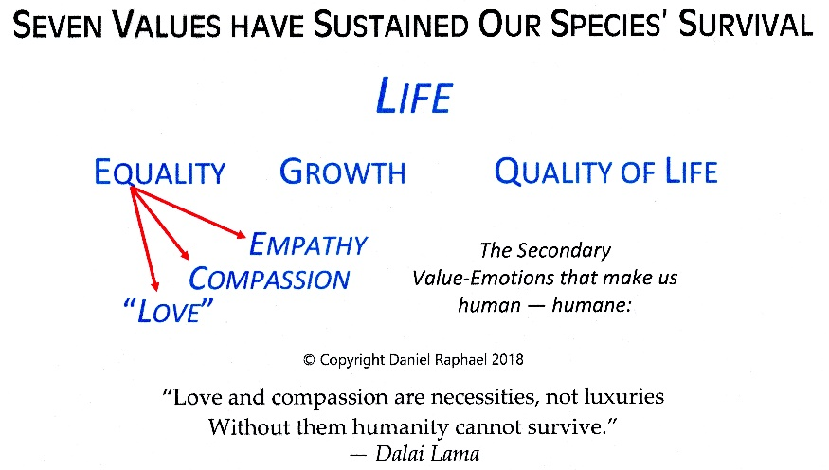
The same motivations people had to form Stage 2 Democracies are the same for forming Stage 3 Democracies. If one does not understand what motivated the authors of the Declaration of Independence, then one will never understand the motivation of citizens to establish Stage 3 Democracies.
Human motivation becomes far more visible when we examine the decisions made by those who are striving to “move up” socially and economically. Often the reasons are a matter of ego satisfaction and pride of accomplishment. Sometimes it is just a matter of a more functional, more efficient, or more durable piece of equipment or democratic system.
For those of us who are highly dissatisfied with the performance of our mature Stage 2 Democracy, what motivates our dissatisfaction? The consistent answer is that people feel restrained and limited in their ability to develop their innate potential and improve their quality of life. As an example, racial discrimination is one of the most egregious restraints upon the incredible potential millions of citizens have who could be making immense contributions to their democratic society IF they were not subject to prejudice and bigotry.
When we begin looking around us to find social, political, and economic restraints and limitations to the expression of our innate needs for equality, we have begun to see that our Stage 2 Democracy falls far short of providing citizens with an improving ability to satisfy their basic needs, improve their quality of life, and to fulfill their lives.
Once we begin asking questions that challenge the blind acceptance of the status quo, we have then begun to “think outside of the box” of conventional, traditional political constraints. For creative groups of individuals, their dissatisfaction simply leads to another question, “I wonder if there are many people who feel the same way, and would like to discover if our antiquarian democracy can be improved or even transformed into a far more evolved form of democracy?” And, “is there another form of the democratic system that is an improvement over what we have now?
When those questions are asked, it is vital that the answers are devised to make certain that the basics of human motivation are taken into account.
—
Considering that citizens in all nations are continuously involved in communication technologies, it is obvious that citizens would choose an option for participating electronically in a transformed democratic system that enables them to participate far more effectively and frequently than voting only every two and four years.
Considering that the experience of 230 years of a Stage 2 Democracy, (See the characteristics of Stage 2 Democracies, page 9), the penchant for public executives (mostly men) to abuse the privileges of their offices, egos for positions of authority, control, and power for example, it seems very reasonable that hundreds of Local Community Design and Validation Teams will be able to provide knowledgeable input to their respective public office holders. Such a system would provide a definite “learning experience” for the Team members and for public executives and their offices. Teams would provide an ongoing oversight function concerning the ethical and moral conduct of office holders, lobbies, and others.

The Antidote to the Apportionment Act of 1911
When all of the factors involved in a functional Stage 3 Democracy are taken into account, the result is a circular democratic process as an integrated system. The beginning place starts, as with any democracy, with concerned local community citizens, or a group of similar-thinking citizens.
The antidote is not more legislation through the archaic Stage 2 Democracy that we are now saddled with, but upon the initiation of hundreds, thousands, of Local Community Design and Validation Teams. Such a large body of people with similar social, political, and economic views that were honed by 1) the seven values, ethics, and morality, 2) Schematic, 3) the Team, and 4) the Design Team Process. There are no existent limitations for this process to begin and to sustain its operation.
Consider the use of the Internet to connect all of the Design Teams in the nation, and with other Design Teams in other nations. This is the real antidote to the Apportionment Act of 1911 — when there are millions of people linked together who are using rational, logical, and humane systems to validate their work and publish it to the world.
“The best way to predict the future is to create it.”

Alan Curtis Kay, 1971, at an early Palo Alto Research Center meeting.
(Also attributed to Peter Drucker and Dandridge M. Cole.)

1. The system begins as do all democracies — with the participation and ingenuity of local citizens in small groups;
2. In this case, 5-11 citizens will be meeting in their Local Community Design and Validation Team. The members of the team have specific roles to play in the “Design Team Process:” Facilitator, Recorder, Inquiring Members, and a “Consultant.” They will be using a “Design and Validation Schematic” that provides a standard format for inquiry so that public issues and problems generate questions. Through the Design Team Process team members develop a synergy for questioning and generating solutions. Later they will submit their “Findings” to the Library of Sustainable Wisdom and to EM21 for sharing with other Teams and inquiring citizens.
3. The intention of EM21 is to facilitate the education of citizens, public executives, governmental bodies and agencies by facilitating the flow of citizen-based, objective, values-based information and suggestions.
EM21 operates much like an Internet subscribership site, as a resource for other teams as is the Library. Teams can partner with other teams in other democracies as well as in their own country to resolve common problems and issues.
This site, too, is a place for publishing positive feedback and suggestions to other teams, office holders, and citizen interest groups. It is also a place to discover individuals who aspire to become office holders using Stage 3 Democratic systems.
4. EMANATION is the not-for-profit corporate organization that supports the operations of EM21, and in part the Library by developing the necessary educational and training materials and technologies for the public. Having Stage 3 Democratic systems accepted by hundreds of millions of citizens of democratic nations will require teaching materials to be easily understood and integrated into their political thinking.
5. This is a circular, self-reinforcing learning system that is designed so that social evolution, political evolution, and economic evolution occur peacefully over time.
Further, as Stage 3 Democracies are based on the fundamental elements of Homo sapiens, community based democratic systems, as the Local Community Design and Validation Teams, are as applicable to one democratic nation as any other. For Stage 3 Democracies to sustain their existence into the centuries and millennia, they must become the responsive and responsible mirror of democratic citizens. Then both become self-sustaining in an ongoing symbiotic, organizationally based relationship.
Their decision-making then takes on the dimensions of the illustration below.
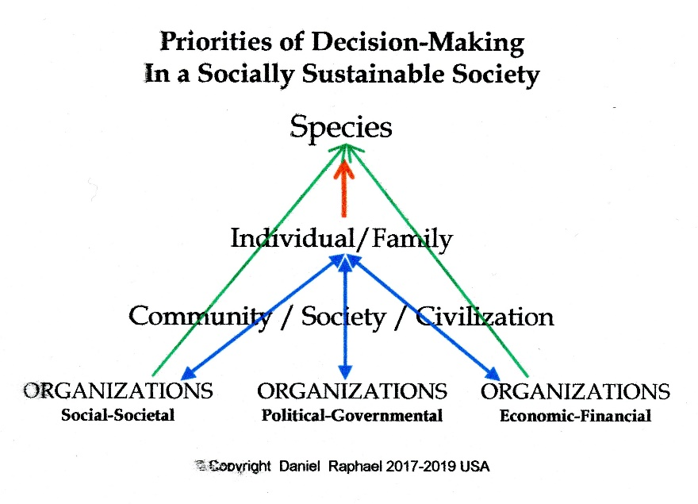

The individual’s right of self-determination,
guided by the responsibilities of liberty,
is the right to actualize the development
of their innate potential.

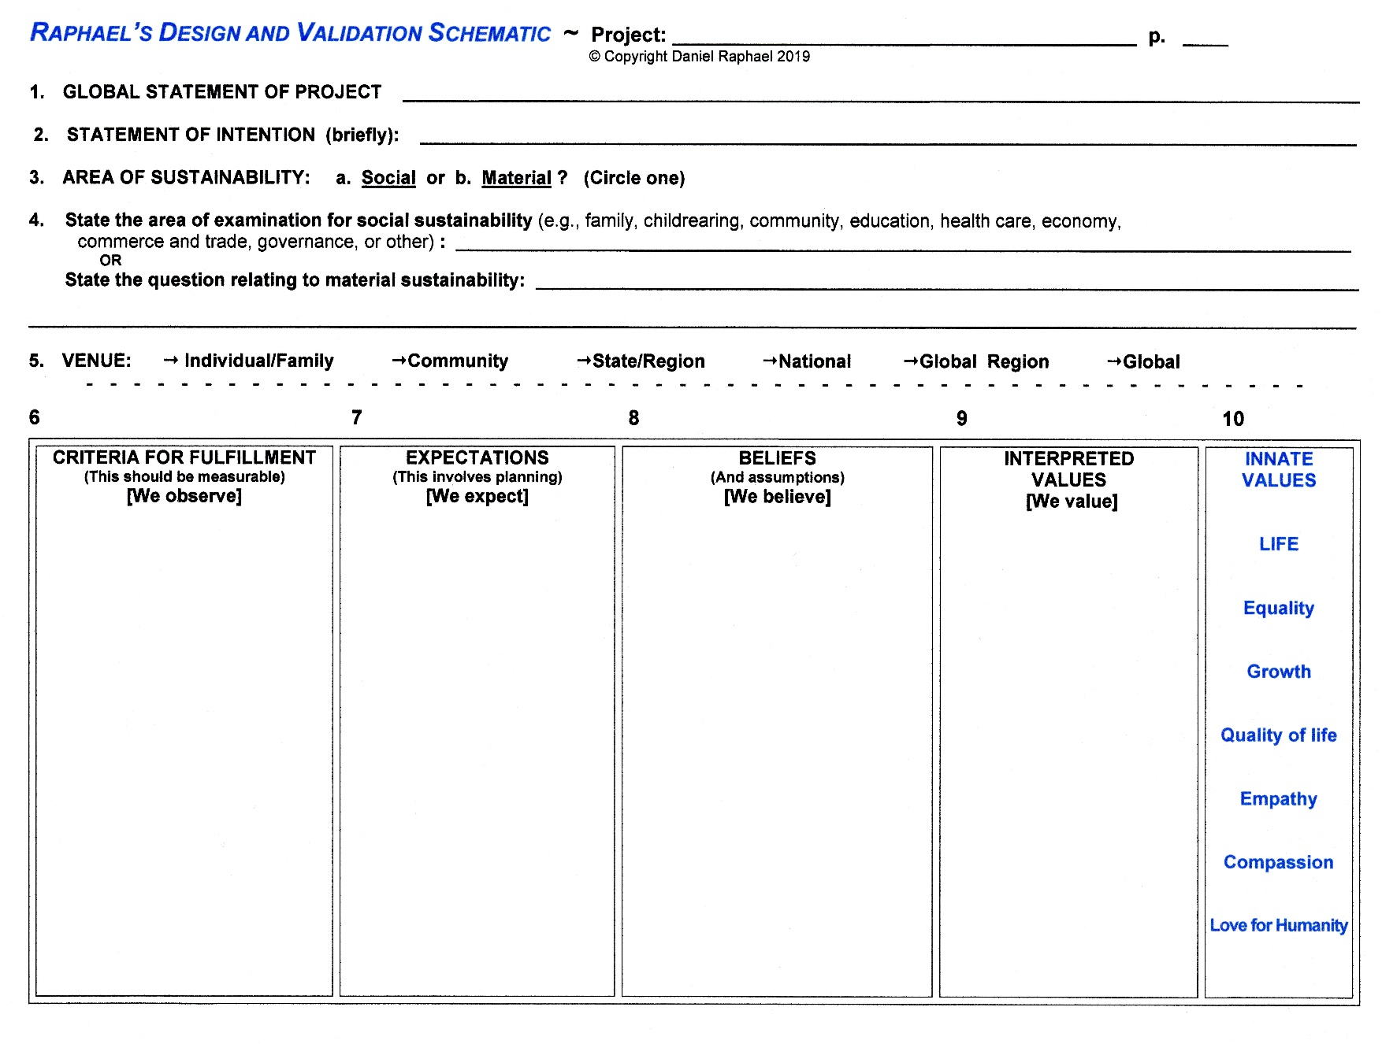

Bibliography

Argyris, Chris, Robert Putnam, Diana M^{c}Clain Smith 1985

Action Science, Concepts, Methods, and Skills for Research

and Intervention

Jossey-Bass Publishers, San Francisco

Bohm, David 2004

On Dialogue, Ed. by Lee Nichol, Preface by Peter M. Senge

Routledge Classics, London

Diamond, Jared 1997

Guns, Germs, and Steel — The Fates of Human Societies

W. W. Norton Co., New York

Diamond, Jared 2005

Collapse – How Societies Choose to Fail or Succeed

Viking, Penguin Group, New York

Diamond, Jared 2019

UPHEAVAL

Little, Brown and Company, New York

Lakoff, George 2008

The Political Mind: Why You Can’t Understand 21st Century Politics with an 18th

Century Brain. Viking, Penguin Group, USA.

Lakoff, George 2006.

Whose Freedom? : The Battle Over America’s Most Important Idea.

Farrar, Straus and Giroux, New York.

Ray, Paul H. Ph.D. 2000
The Cultural Creatives: How 50 Million People Are Changing the World.
Three Rivers Press, New York.

Raphael, Daniel
Multiple entries. See BIO for book list and URL for downloads.

Senge, Peter M. 1994

The Fifth Discipline — The Art & Practice of the Learning Organization

Currency Doubleday, New York

Sesno, Frank 2017

Ask More : The Power of Questions to Open Doors,

Uncover Solutions, and Spark Change

New York, New York AMACOM

ISBN: 9780814436714 (Hardcover): ISBN: 9780814436721 (e-book)

Wright, Kurt 1998

Breaking the Rules – Removing the Obstacles to Effortless High Performance

CPM Publishing, Boise, ID ISBN: 0-9614383-3-9

BIO: Daniel Raphael, PhD
Daniel Raphael is an independent and original thinker. He is a Vietnam veteran with 18 years experience working in adult felony criminal corrections; father of three and grandfather of four children; former volunteer fireman, small business owner, inventor, and manufacturer of a household sewing machine product; self-taught theologian, ethicist, and holistic life coach; principal of Daniel Raphael Consulting since 2003; and a remarkably unsuccessful self-published author of numerous books, papers, and articles. Daniel enjoys public speaking and has taught numerous classes and workshops nationally and internationally.
Education
Bachelor of Science, With Distinction, (Sociology).
Arizona State University, Tempe, Arizona.
Master of Science in Education
(Educationally and Culturally Disadvantaged),
Western Oregon University, Monmouth, Oregon.
Doctor of Philosophy (Spiritual Metaphysics),
University of Metaphysics, Sedona, Arizona.
Masters Dissertation: A Loving-God Theology
Doctoral Dissertation: A Pre-Creation Theology

Achievements
* Creator of The EMANATION Process, the core process of Stage 3 Democracies.
* Creator of The Design Team Process, which incorporates the seven values
and subsequent ethics and morality, the Raphael Design and Validation Schematic, and specific Design Team member roles.
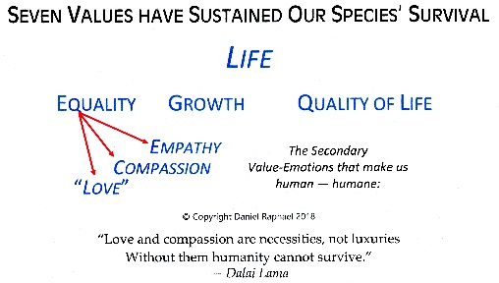
* Discoverer of the seven innate values of the Homo sapiens species
* Creator of the Raphael Unified Theory of Human Motivation
* Creator of the Raphael Unified Theory of Social Change
* Originator of A Unique, Unified Theory of Ethics,
Morality, and Values
* Creator of Learning Centers for Sustainable Families
* Discoverer of the Four Foundations for Sustainable Civilizations
* Creator of the Raphael Premise and Hypothesis for the Existence of Dark Matter and the Increasing Rate of Expansion of the Universe

Writer, Author, Publisher
● https://sites.google.com/view/danielraphael/free-downloads
(1992) The Development of Public Policy and the Next Step of Democracy for the 21st Century, NBHCo.
(1992) Developing A Personal, Loving-God Theology, NBHCo
(1999) Sacred Relationships, A Guide to Authentic Loving, Origin Press [OOP] Available from the author.
(2002) What Was God Thinking?!, Infinity Press ISBN 0-9712663-0-1 or from the author.
(2007) Global Sustainability and Planetary Management
(2014) Healing a Broken World, Origin Press [OOP]
● (2014, 2019) The Design Team Process
(2015) Social Sustainability HANDBOOK for Community-Builders, Infinity Press. Available from the author.
● (2016, 2019) The Progressive’s Handbook for Reframing Democratic Values

● (2016) Organic Morality: Answering the Critically Important Moral Questions of the 3rd
Millennium
● (2017) Designing Socially Sustainable Democratic Societies
● (2017) A Theology for New Thought Spirituality
● (2017) God For All Religions — Re-Inventing Christianity and the Christian Church — Creating Socially Sustainable Systems of Belief and Organization
● (2017) God For All Children, and Grandchildren
● (2017) Learning Centers for Sustainable Families and the Millennium Families Program
● (2018) The Values God Gave Us
● (2018) Understanding Social Sustainability
● (2017) Pour Comprendre la Viabilité Sociale
● (2017) Entendiendo La Sostenibilidad Social
● (2018) Making Sense of Ethics — A Universally Applicable Theory of Ethics,
Morality, and Values
● (2018) Answering the Moral and Ethical Confusion of Uninvited Immigrants
● (2018) Restoring the Greatness of Democratic Nations — A Radically Conservative and
Liberal Approach
● (2018) Artificial Intelligence, A Protocol for Setting Moral and Ethical Operational
Standards
● (2019) Sustainable Civilizations, A General Critical Theory Based on the Innate Values of
Homo Sapiens
● (2019) Seven Innate Human Values — The Basis for Consistent Ethical Decision-Making
● (2019) Foundations for an Evolving Civilization
● (2019) Thought Adjuster and the Conscious Mind
● (2019) The Raphael Premise and Hypothesis for the Existence of Dark Matter and the
Increasing Rate of Expansion of the Universe
● (2020) Quantum Spiritual Metaphysics
● (2020) A Feminine Theology for Islam and Catholicism
● (2020) Peace and the Underlying Logic of Innate Human Goodness
(2020) Stage 3 Democracies
(2020) Societal Morality
(2020) The Logic of Values-Based Inquiry for Decision-Making

Contact Information:
Daniel Raphael, PhD
Cultural Agent Provocateur
Cultural Leadership Training and Consulting
https://sites.google.com/view/danielraphael/free-downloads
daniel.raphaelphd@gmail.com ● + 1 303 641 1115
PO Box 2408, Evergreen, Colorado 80437 USA
https://bigmacspeaks.life

Dream no small dreams for they have no power
to move the hearts of men [and women].

Johann Wolfgang von Goethe, 1749-1832

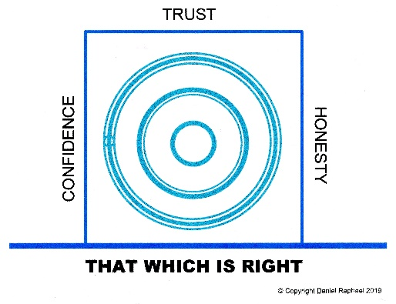

Raphael, Daniel 2020 Understanding Social Sustainability Available as a free PDF from https://sites.google.com/view/danielraphael/free-downloads
Raphael, Daniel 2020 Seven Innate Human Values
Raphael, Daniel 2020 Making Sense of Ethics — A Universally Applicable Theory of Ethics, Morality and Values https://sites.google.com/view/danielraphael/free-downloads
Raphael, Daniel 2014-2020 The Design Team Process, A Local Community Empowerment Tool. https://sites.google.com/view/danielraphael/free-downloads
U.S. Voting Rights http://www.infoplease.com/timelines/voting.html#ixzz1cB0NYYVf
ibid, Raphael The Design Team Process, ….
Wright, Kurt 1998. Breaking The Rules, Removing Obstacles to Effortless High Performance, CPM Publishing, Boise, ID
ibid, Raphael Making Sense of Ethics …. p 36
Raphael, Daniel 2015 Social Sustainability — Designing Sustainable Democracies Unpublished. Available directly from the author as a PDF document. ALSO Raphael, Daniel 2011 Virtual - Sustainable - Organic Democracy Unpublished. Available directly from the author as a PDF document.
Raphael, Daniel 2020 The Design Team Process — A Local Community Empowerment Tool Available as a free downloadable PDF from https://sites.google.com/view/danielraphael/free-downloads
Raphael, Daniel 2019 Sustainable Civilizations, A General Critical Theory Based on the Innate Values of Homo Sapiens See Part 3, “Preparing for an Unsure Future,” p 141-245. https://sites.google.com/view/danielraphael/free-downloads

